**Application Form Website**

1. **Login Page:** In login form user enter User id and Password , without enter user id and password user will not able to enter into the system

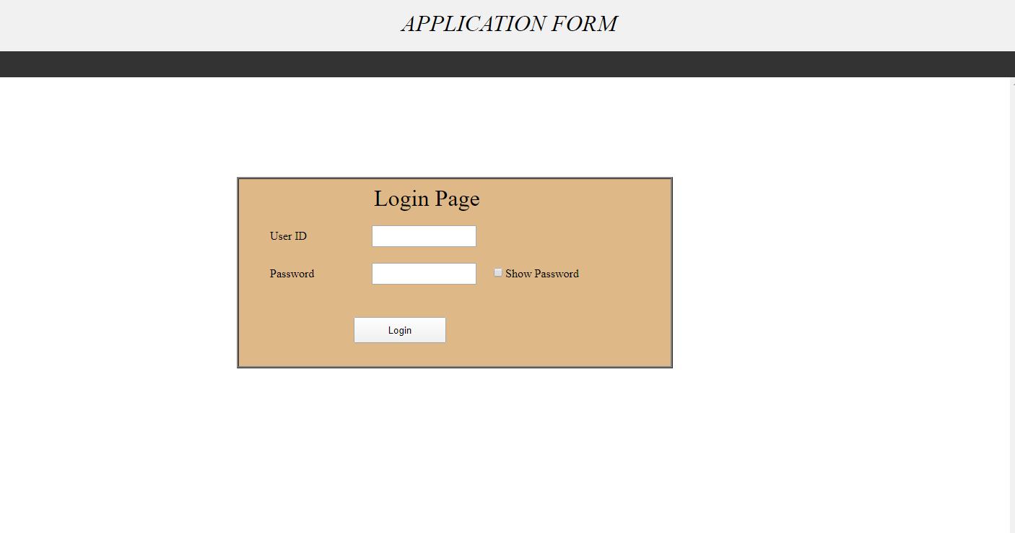

1. **Application Form:** In Application Form User fill all the details and after click submit button all the details will be saved into database table

* User need to fill all the fields. If user left any fields then it will give error message
* If user wants to see all the records then click on view form details button then they can show all the details
* If user wants to change Password then click on change password
* If user wants to logout then click on logout button

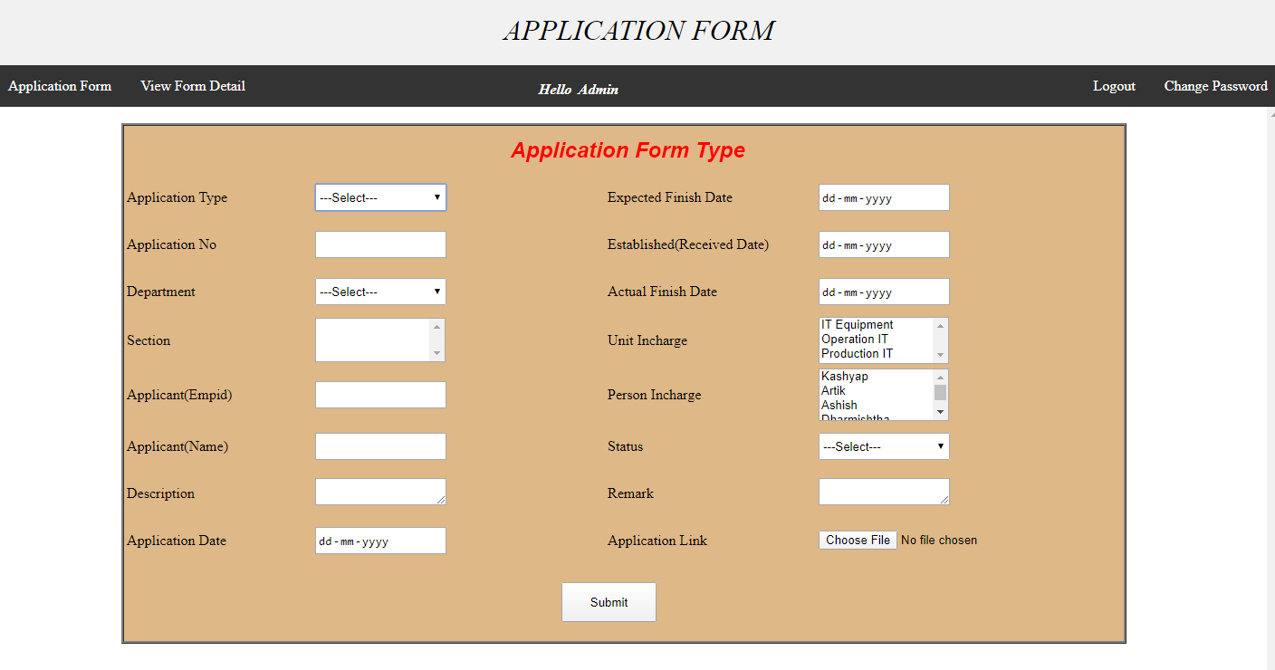

1. **View Form Details :** In view form details form user can see all the details of the application form which was insert into the database table

In this form user can search the details by Department, Section, Application Date, Status or Person In charge

* If user wants to update the details then user click on edit button and change the details and click update button
* If user wants to delete the record then click on delete button
* In this form if user export data into excel sheet then click on export to excel button
* If user wants to fill new form details then click on application form button

